State Diagram implementation

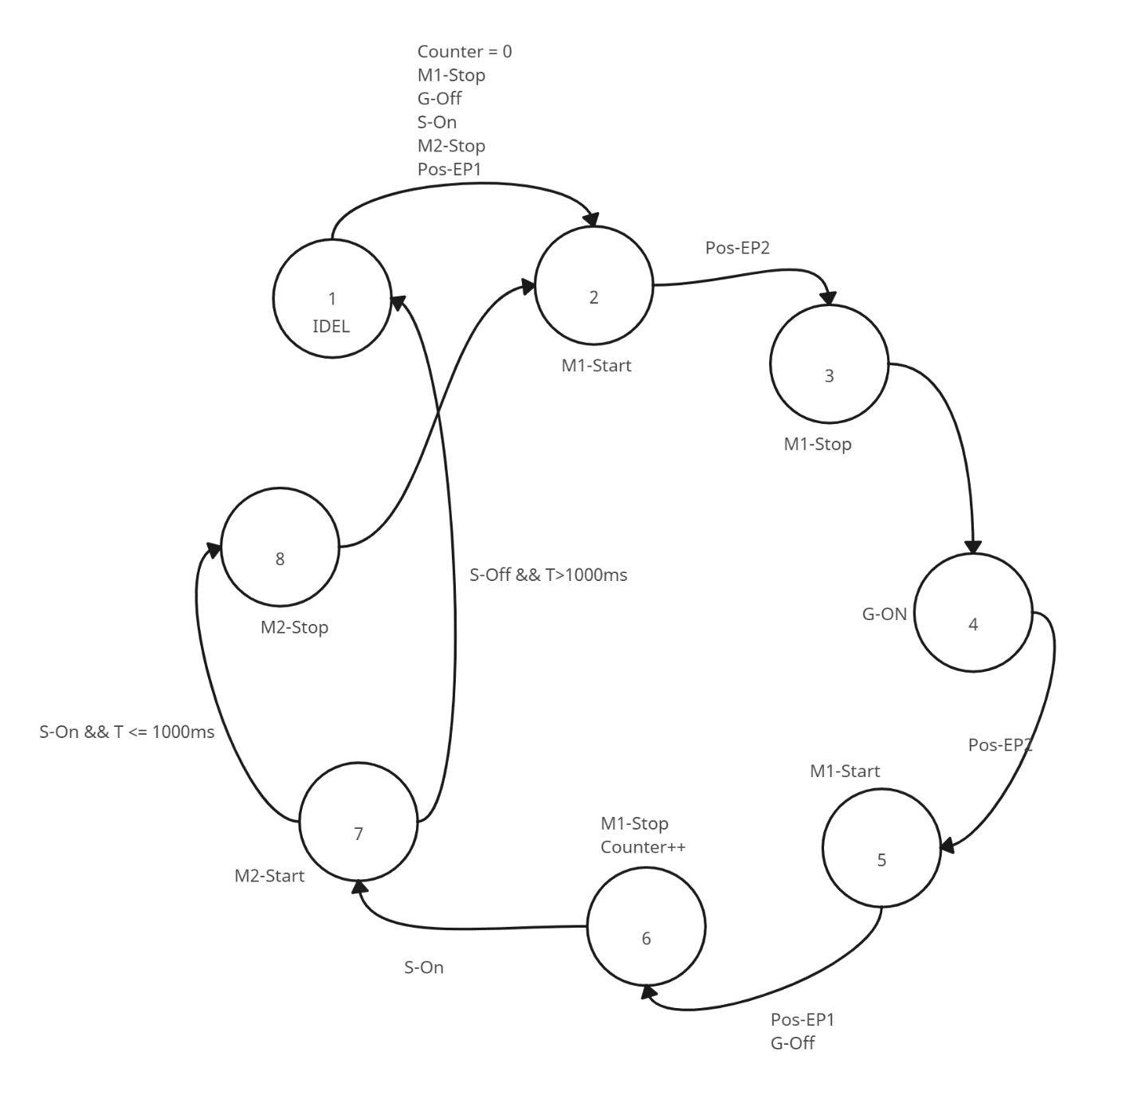

Description

1. Ideal - Initial home position
2. Counter – pick and place cycle counter
3. M1 – linear axis slide motor
4. M2 – spinning disk motor
5. G – gripper
6. S – NO (NPN) cylinder presence sensor
7. Pos EP1 – End position linear axis 1 (place side)
8. Pos EP2 – End position linear axis 2 (pick side)
9. T – Cycle time between each cylinder